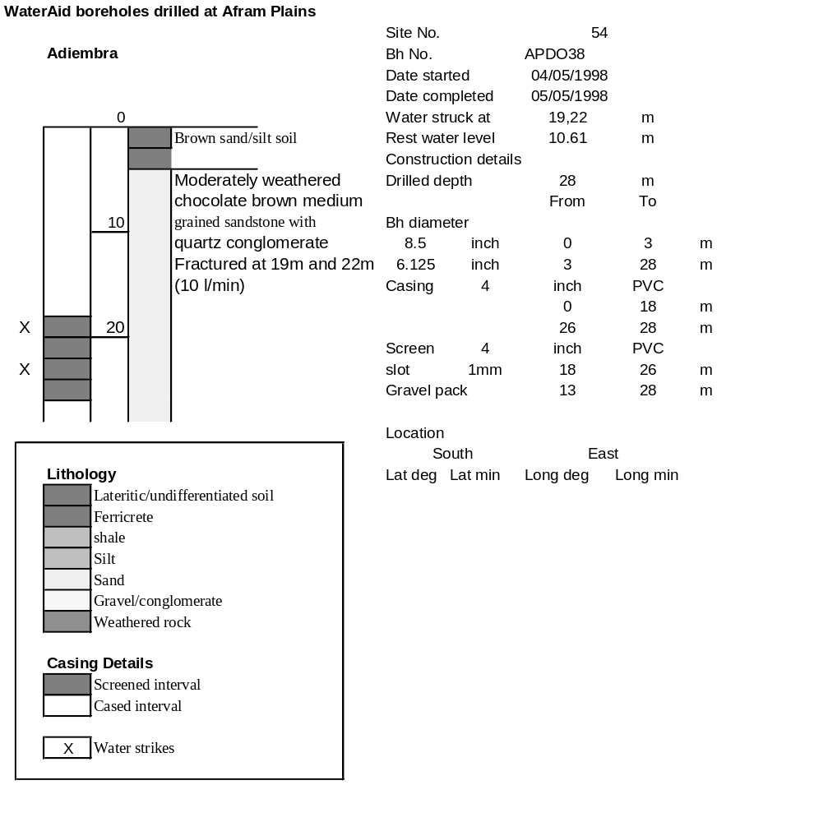

Ghana | Test pumping
Borehole No. |  | APDO38
Hole No |  | 54 | (4)
Village |  | Adiembara
Date |  | 16/11/1998
Point above GL |  | 0.66 | m
Pump depth |  | 27 | m
SWL |  | 11.27 | m
Start Time |  | 13:25
Drawdown test |  |  |  |  | Recovery Test
time | pwl (m) | Q l/min | dd | sc(q/s) | Time | wl (m) | t/t' | resdd
0.00 | 11.27 | 15.00 | 0.00 |  | 0.00 | 17.29 |  | 6.02
1.00 | 12.66 | 15.00 | 1.39 | 10.79 | 1.00 | 16.48 | 241.00 | 5.21
2.00 | 12.93 | 15.00 | 1.66 | 9.04 | 2.00 | 15.64 | 121.00 | 4.37
3.00 | 13.18 | 15.00 | 1.91 | 7.85 | 3.00 | 15.27 | 81.00 | 4.00
4.00 | 13.54 | 15.00 | 2.27 | 6.61 | 4.00 | 14.79 | 61.00 | 3.52
5.00 | 13.97 | 15.00 | 2.70 | 5.56 | 5.00 | 14.28 | 49.00 | 3.01
6.00 | 14.37 | 15.00 | 3.10 | 4.84 | 6.00 | 13.87 | 41.00 | 2.60
7.00 | 14.78 | 15.00 | 3.51 | 4.27 | 7.00 | 13.50 | 35.29 | 2.23
8.00 | 15.13 | 15.00 | 3.86 | 3.89 | 8.00 | 13.21 | 31.00 | 1.94
9.00 | 15.44 | 15.00 | 4.17 | 3.60 | 9.00 | 12.95 | 27.67 | 1.68
10.00 | 15.72 | 15.00 | 4.45 | 3.37 | 10.00 | 12.55 | 25.00 | 1.28
12.00 | 16.05 | 15.00 | 4.78 | 3.14 | 12.00 | 12.29 | 21.00 | 1.02
14.00 | 16.38 | 15.00 | 5.11 | 2.94 | 14.00 | 12.20 | 18.14 | 0.93
16.00 | 16.62 | 15.00 | 5.35 | 2.80 | 16.00 | 12.14 | 16.00 | 0.87
18.00 | 16.78 | 12.00 | 5.51 | 2.18 | 18.00 | 12.10 | 14.33 | 0.83
20.00 | 16.83 | 12.00 | 5.56 | 2.16 | 20.00 | 12.02 | 13.00 | 0.75
25.00 | 16.90 | 12.00 | 5.63 | 2.13 | 25.00 | 11.91 | 10.60 | 0.64
30.00 | 16.95 | 12.00 | 5.68 | 2.11 | 30.00 | 11.85 | 9.00 | 0.58
35.00 | 17.00 | 12.00 | 5.73 | 2.09 | 35.00 | 11.81 | 7.86 | 0.54
40.00 | 17.02 | 12.00 | 5.75 | 2.09 | 40.00 | 11.79 | 7.00 | 0.52
45.00 | 17.04 | 12.00 | 5.77 | 2.08 | 45.00 | 11.77 | 6.33 | 0.50
50.00 | 17.05 | 12.00 | 5.78 | 2.08 | 50.00 | 11.76 | 5.80 | 0.49
55.00 | 17.05 | 12.00 | 5.78 | 2.08 | 55.00 | 11.75 | 5.36 | 0.48
60.00 | 17.06 | 12.00 | 5.79 | 2.07 | 60.00 | 11.72 | 5.00 | 0.45
70.00 | 17.08 | 12.00 | 5.81 | 2.07 | 70.00 | 11.70 | 4.43 | 0.43
80.00 | 17.10 | 12.00 | 5.83 | 2.06 | 80.00 | 11.68 | 4.00 | 0.41
90.00 | 17.13 | 12.00 | 5.86 | 2.05 | 90.00 | 11.65 | 3.67 | 0.38
100.00 | 17.14 | 12.00 | 5.87 | 2.04 | 100.00 | 11.63 | 3.40 | 0.36
110.00 | 17.16 | 12.00 | 5.89 | 2.04 | 110.00 | 11.61 | 3.18 | 0.34
120.00 | 17.18 | 12.00 | 5.91 | 2.03 | 120.00 | 11.60 | 3.00 | 0.33
130.00 | 17.20 | 12.00 | 5.93 | 2.02
140.00 | 17.22 | 12.00 | 5.95 | 2.02
150.00 | 17.25 | 12.00 | 5.98 | 2.01
160.00 | 17.26 | 12.00 | 5.99 | 2.00
170.00 | 17.27 | 12.00 | 6.00 | 2.00
180.00 | 17.26 | 12.00 | 5.99 | 2.00
190.00 | 17.26 | 12.00 | 5.99 | 2.00
200.00 | 17.27 | 12.00 | 6.00 | 2.00
210.00 | 17.28 | 12.00 | 6.01 | 2.00
220.00 | 17.29 | 12.00 | 6.02 | 1.99
230.00 | 17.29 | 12.00 | 6.02 | 1.99
240.00 | 17.29 | 12.00 | 6.02 | 1.99

